Multiple-choice section – choose the correct answer

Question 1 [7.1]

For the triangle shown, which of the following represents the ratio  for the angle *a*?

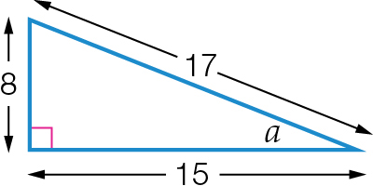

A B C D 

Question 2 [7.2]

If sin(θ) = , then the value of *X* in the diagram below is:

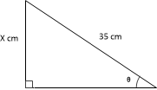

A 5 B 7 C 21 D 28

Question 3 [7.3]

Which equation can be used to find the value of *k* in the diagram?

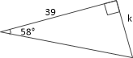

A sin(58°) =  B cos(58°) =  C tan(58°) =  D tan(58°) = 

Question 4 [7.4]

The value of θ can be found by using which of the following equations?

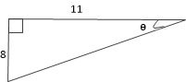

A cos(θ) =  B sin(θ) =  C tan(θ) =  D sin(θ) = 

Question 5 [7.5]

A 10.7 m tree casts a shadow across the ground. If the angle of elevation of the sun is 43°, the length of the shadow is closest to:

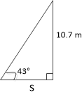

A 7.8 m B 10 m C 11.5 m D 15.7 m

Question 6 [7.5]

A bearing of 329°T, written as a compass bearing, is:

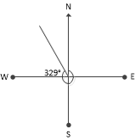

A N31°E **B** S29°W **C** N31°W **D** S31°E

Multiple-choice results: \_\_\_ / 6

Short answer section

Question 7 3 marks [7.5]

The bottom of the slide is 2.8 m away from the base of the supporting pole. If , find the length of the slide.

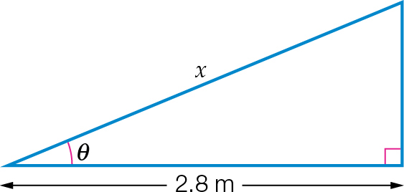

Question 8 3 marks [7.5]

A motorcyclist travels 13 km north, then 9 km east. Find his bearing from the starting point to the nearest degree.

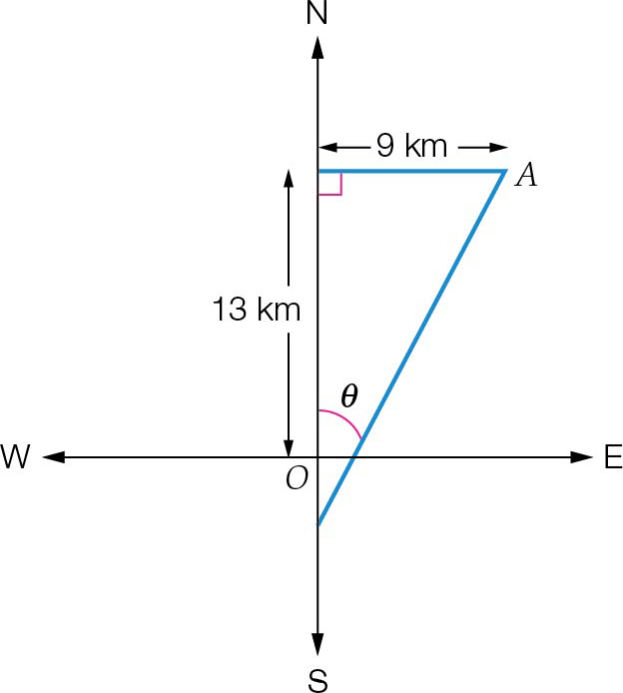

Question 9 3 marks [7.1]

A right-angled triangle has sides of length 9 cm, 40 cm and 41 cm.

**(a)** Which of these sides would be the hypotenuse?

**(b)** Draw a diagram of the triangle with the vertices labelled *A*, *B* and *C* and the right angle at *B*. Mark the side lengths on the diagram.

Question 10 4 marks [7.3]

Find the value of the unknown lengths, correct to 1 decimal place.

|  |  |
| --- | --- |
| **(a)**  ACPM9_PR_7_08tsc | **(b)** |

Question 11 4 marks [7.4]

Find the value of θ, correct to the nearest degree, in each of the following.

|  |  |
| --- | --- |
| **(a)**  ACPM9_PR_7_12tsc | **(b)**  ACPM9_PR_7_10tsc |

Question 12 2 marks [7.3]

A supporting wire is attached 7.4 m up a pole. If the wire makes an angle of 48° with the ground, find the distance from the pole to the wire. Give your answer correct to 1 decimal place.

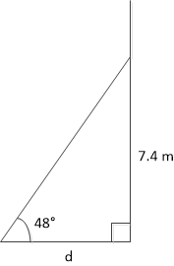

Question 13 3 marks [7.5]

The angle of elevation to the top of a mobile phone tower from a point 170 m from the base is 38°.

**(a)** Draw a sketch of the information provided.

**(b)** Find the height of the tower, correct to 1 decimal place.

Short answer results: \_\_\_ / 22

Extended answer section

Question 14 6 marks [7.5]

A 9 m long ladder is leaning against a building inclined at an angle of 56° with the ground.

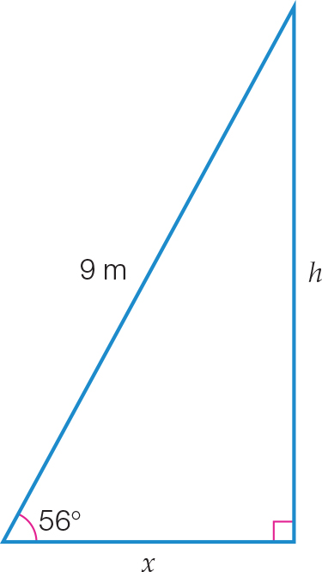

**(a)** At what height does the ladder touch the building, correct to 2 decimal places?

**(b)** What is the distance between the foot of the ladder and the building, correct to 2 decimal places?

**(c)** Find the angle the ladder is making with the building, to the nearest degree.

Question 15 6 marks [7.5]

A hiker begins walking from a car park at point *P*. She walks 2.5 km due east, then turns and walks 4 km due south to point *Q*.

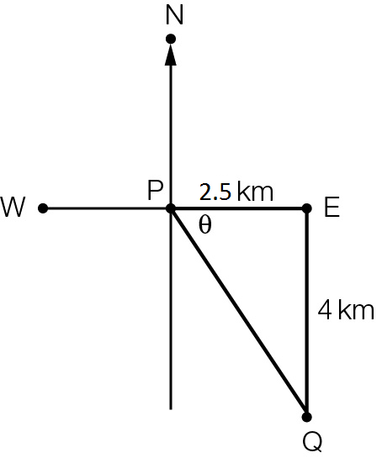

**(a)** **(i)** Find the value of the angle θ, correct to the nearest degree.

**(ii)** use your answer to **(i)** to find the true bearing of *Q* from *P*.

**(b)** **(i)** If the hiker walks from *Q* directly back to her starting point *P*, how far will she walk?   
 State your answer correct to 1 decimal place.

**(ii)** Find the total distance she will have walked after returning directly back to point *P*.

Extended answer results: \_\_\_ / 12

TOTAL test results: \_\_\_ / 40